Chairwoman Eddie Bernice Johnson (D-TX)

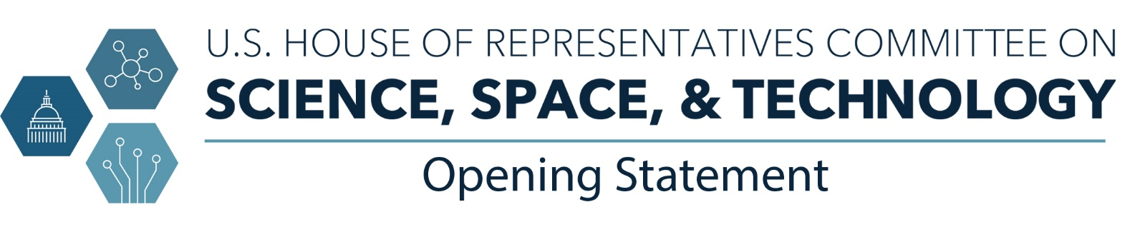
Subcommittee on Research and Technology Hearing:
Building a Workforce to Navigate the Electric Vehicle Future
May 20, 2022

Good morning and thank you to Chairwoman Stevens for holding today’s hearing. I look forward to a fruitful discussion about the workforce needs that must be addressed in order to usher in a bright future for the electric vehicle industry.

Building a STEM workforce equipped to meet the needs of this country’s emerging industries is an urgent national challenge. The Committee on Science, Space, and Technology has worked tirelessly over the past two years to develop important provisions that have been included in the America COMPETES Act. This landmark bill will accelerate progress on key emerging technologies like quantum computing, artificial intelligence, biotechnology, and clean energy technologies that power electric vehicles. These technologies have the potential to launch entirely new industries. They will help address pressing societal challenges like climate change. They will bolster our economy and our national security.

I am immensely proud of what we’ve been able to achieve on a bipartisan basis. But the vision laid out in COMPETES can only be realized if we have a skilled STEM workforce in place to translate research and innovation into products and services.

We need more technicians, manufacturers, software developers, engineers, and scientists to come to the table. We need to foster an inclusive culture to ensure students and workers from all backgrounds can contribute their talents. Let me be clear, our shortage of STEM workers is holding us back. At the very moment when our global competitors and adversaries are pulling ahead on critical technologies, we are struggling to keep pace. It is time we learned a hard lesson from our past mistakes. We cannot race ahead in developing cutting edge technologies without building the workforce critical to ensuring Americans will reap the benefits.

Thank you, again to Chairwoman Stevens for holding this important hearing. I yield back.

